Poster description for The 8th ICMAP & 9th ISFM

(16 point font)

Gil-Dong Hong¹ and Sedol Lee²

¹Korea National University, Korea
²Korea Institute of Plasma Science, Korea

Poster Number: 00C1234

The 8th International Conference on Microelectronics and Plasma Technology (ICMAP) and the 9th International Symposium on Functional Materials (ISFM) will be held through On/Off hybrid conference format. Authors of poster presentation are invited to upload this poster description with any style but it is not mandatory.

However, the poster description would be helpful to understand the authors work because the poster will be displayed on-line site. Therefore, ICMAP and ISFM Program Committee encourage the submission of this poster description. A poster description should be written on A4 Standard (21 cm x 29.7 cm) with title, affiliation and poster description including figures in a double column. The length of document around (3 – 4) pages is recommended for the readers and should be less than 8 pages. All other style formatting is up to the authors. Authors can describe their posters following page numbers or sections.

This document is not a short paper or conference proceeding. Freely describe what the authors want to focus or highlight.

For example, this page is following typical conference proceeding style. However, the next page is one of the free style describing each poster page.

Please make sure that all the figures/photographs are clearly visible. The file format of the poster description should be in PDF.

REFERENCES:
[1]T. First Author, “Paper Title”, The Journal/Proceedings Name, 9, 825 (2021).

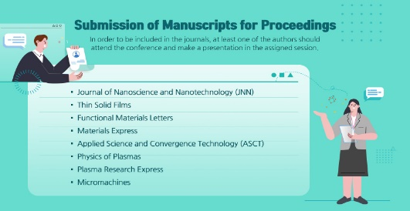
Figure 1. Journal lists

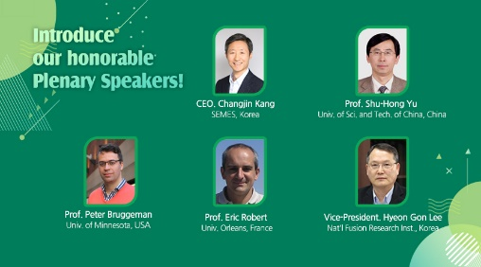
Figure 2. List of plenary speakers

This page describes the list of journals. The submitted regular manuscripts will be published in Journal of Nanoscience and Nanotechnology (JNN), Thin Solid Films, and Functional Materials Letters, Materials Express, Applied Science and Convergence Technology (ASCT), Physics of Plasmas, Plasma Research Express, Micromachines after peer reviews.

In order to be included in the journals, at least one of the authors should attend the conference and make a presentation in the assigned session.

On the other hand, this figure shows the list of our honorable plenary speakers. The plenary speakers will present the most interesting topics in plasma science, equipment and current status of academic and industrial achievements.
Therefore, we are welcome any style of poster description document if the authors choose their own style.

